FLOWCHART INSTRUCTION GUIDE

BOXES WITH SOLID LINES AROUND THEM (FIGURE 1) ARE USED AS MAJOR QUESTIONS TO BE ANSWERED IN THE DECISION-MAKING PROCESS. THEY DO NOT CONTAIN LINKS TO ADDITIONAL DOCUMENTATION.

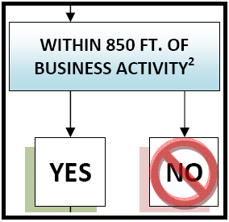
FIGURE 1

BOXES WITH DASHED LINES AROUND THEM (FIGURE 2) CONTAIN LINKS TO ADDITIONAL INFORMATION. TO SEE THE RELATIVE REGULATIONS HOLD DOWN THE CONTROL (Ctrl) KEY AND CLICK THE LEFT MOUSE BUTTON WHILE THE CURSOR IS OVER THE BOX.

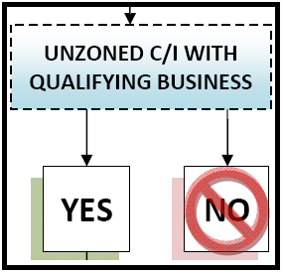
FIGURE 2

LINKS ARE USED TO ACCESS THE REGULATIONS. WHEN THE REGULATIONS ARE DISPLAYED THEY MAY CONTAIN ADDITIONAL INTERNAL LINKS TO DEFINITIONS OR ADDITIONAL REGULATIONS THAT RELATE TO THE TOPIC. LINKED PAGES MAY ALSO CONTAIN COLORED TEXT.

TO CLOSE A LINKED DOCUMENT CLICK ON THE “X” ON THE TOP RIGHT OF THE MSWORD APLICATION.

